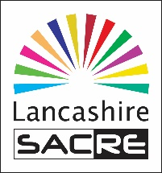
Report to Lancashire SACRE: October 2020

- The following materials were added to the website during the partial closure of schools:
- RE policy template for primary schools. http://www.lancsngfl.ac.uk/curriculum/re/index.php?category_id=21
- EYFS exemplifications – all exemplification materials to support the syllabus are now complete for all year groups.
http://www.lancsngfl.ac.uk/curriculum/re/index.php?category_id=28
- Additional guidance relating to developing spirituality across the curriculum.
- A newsletter signposting schools to resources to support online learning.

- Planned training with LAT Blaylock on improving subject knowledge in the teaching of Hinduism and Islam was cancelled and has been moved to 21st October.

- Network meetings were cancelled. At the moment schools do not have the capacity to release our associate consultants. These might be provided online in the future.

- A monitoring report cannot be provided due to a lack of data for analysis. Outcomes from Inspections, assessments and pupil attitude questionnaires are unavailable. A draft slimmed down annual report will be written to share with members in November.

- Consultants continue to write new resources to support the statutory review of the syllabus; these will be shared with the newly formed ASC in due course.

- The LA have maintained the same level of funding for the SACRE for 2020/21.

- The NNWHub has sadly not been able to meet due to COVID restrictions and no face to face meetings are planned for the immediate future. Perhaps a virtual meeting can be arranged.

- SACRE are asked to consider:

- A protocol for monitoring RE curriculum information on school websites.
- A protocol for school visits in the future once restrictions are relaxed.

